**Puppet/Docker Project**

EC2 Instances

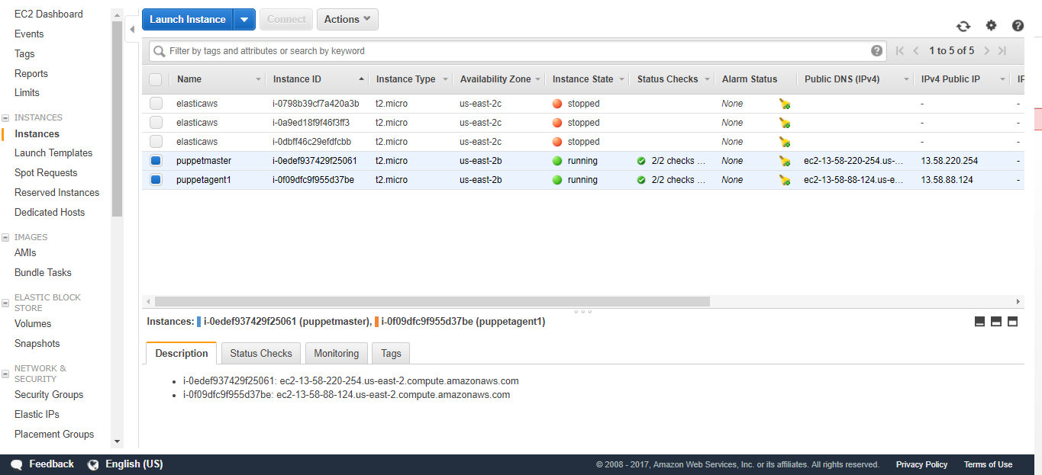

Security rules (port 8140 open for puppet, 22 open for SSH)

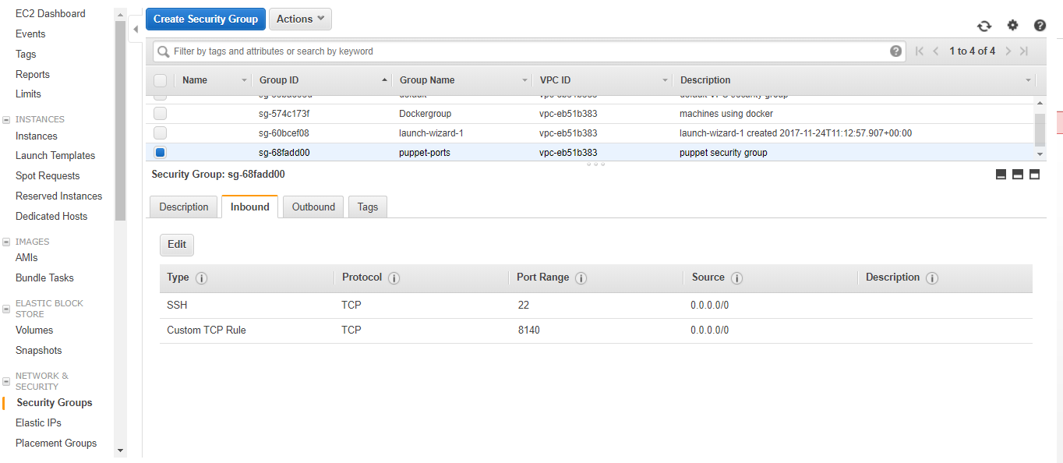

Puppet installed and running on the master instance.

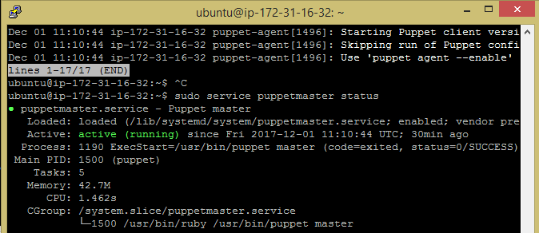

Puppet agent installed and running on the agent node instance.

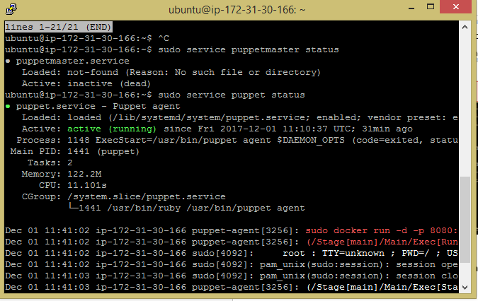

Puppet site.pp file (Puppet manifest)

* Agents will get Docker and use it to pull a Jenkins image and run it.

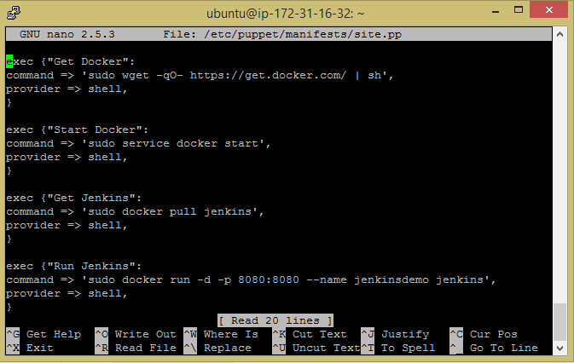

Puppet.conf file (Master instance)

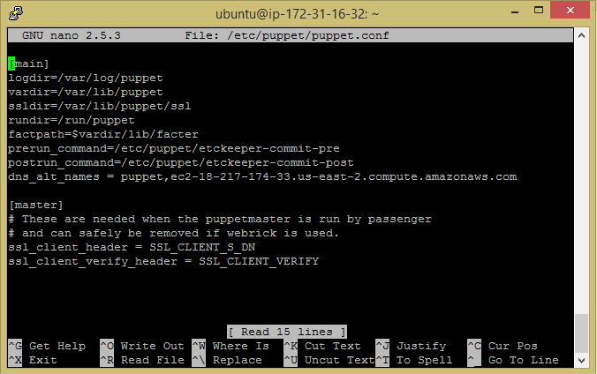

Puppet.conf file (Agent instance)

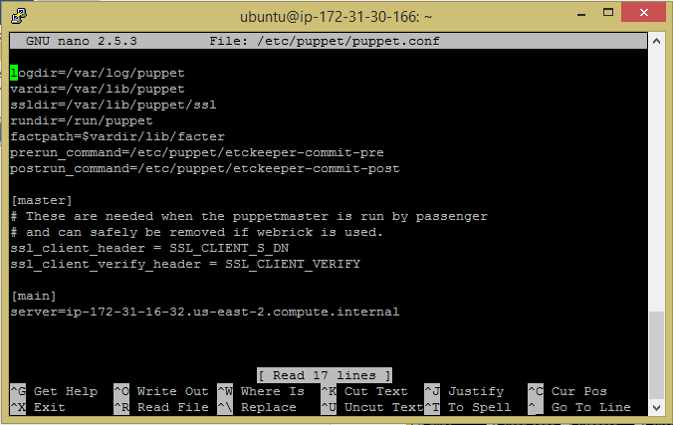

Hosts file (Master instance)

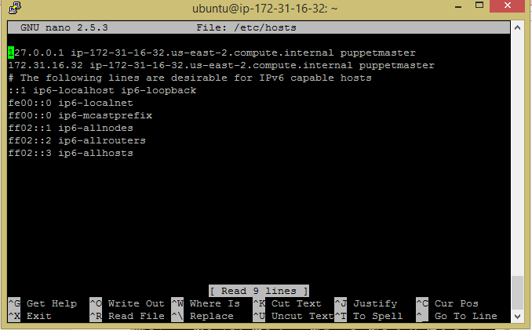

Hosts file (Agent instance)

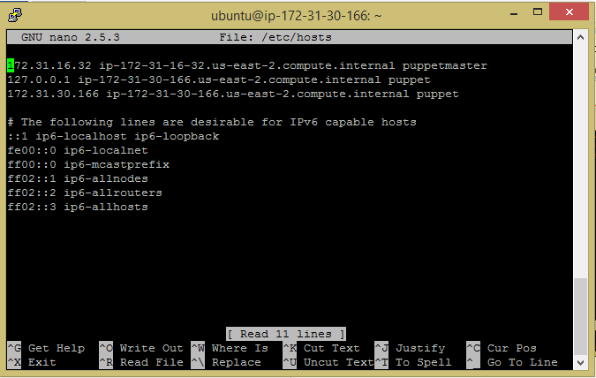

Successful execution, Puppet manifest obtained from the Master instance and carried out on the Agent instance.

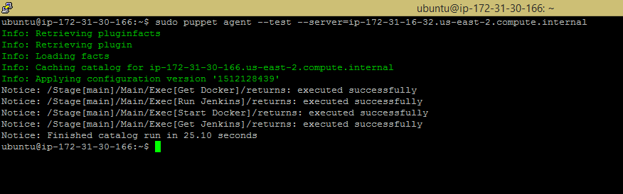

Container is running normally.



**Deployment from Master to Agent was successful.**